NADPVIC2021: Joining the dots of inclusive practice – what is the picture now?

From Reasonable Adjustments to Inclusive Practice? Exploring the influence of lecture capture technology on the academic outcomes and learning experiences of disabled students in higher education

John Harding, University of Cambridge

Slide 1: Introduction
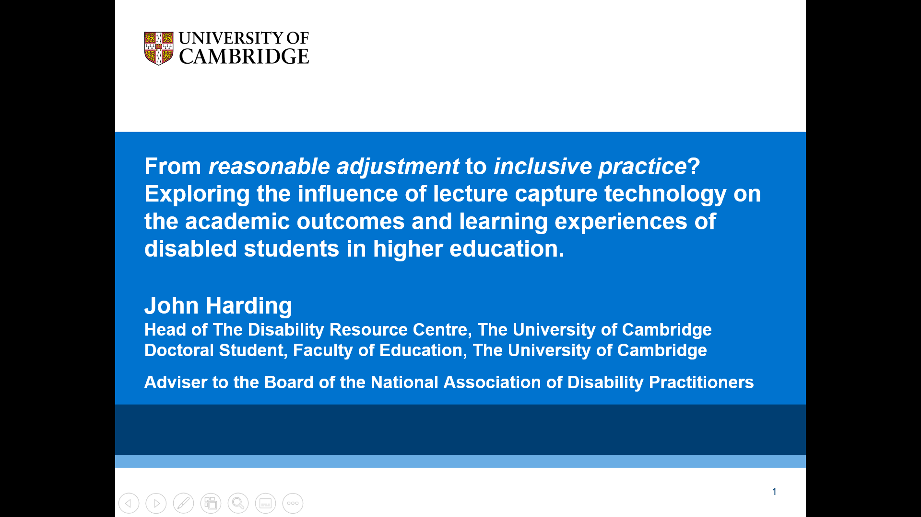

My name is John Harding. I'm the Head of the Disability Resource Centre at the University of Cambridge. I'm also an adviser to the National Association of Disability Practitioners in the UK. I'm also a doctoral student. I'm studying for a Doctorate in Education at the Faculty of Education here at Cambridge, and I'm going to talk about briefly today about my research into inclusive practice, so I'm just going to share my screen.
So, my talk today is called 'From reasonable adjustments to inclusive practice? Exploring the influence of lecture capture technology on the academic outcomes and learning experiences of disabled students in higher education."

Slide 2: Disability, Disability Support and Technology
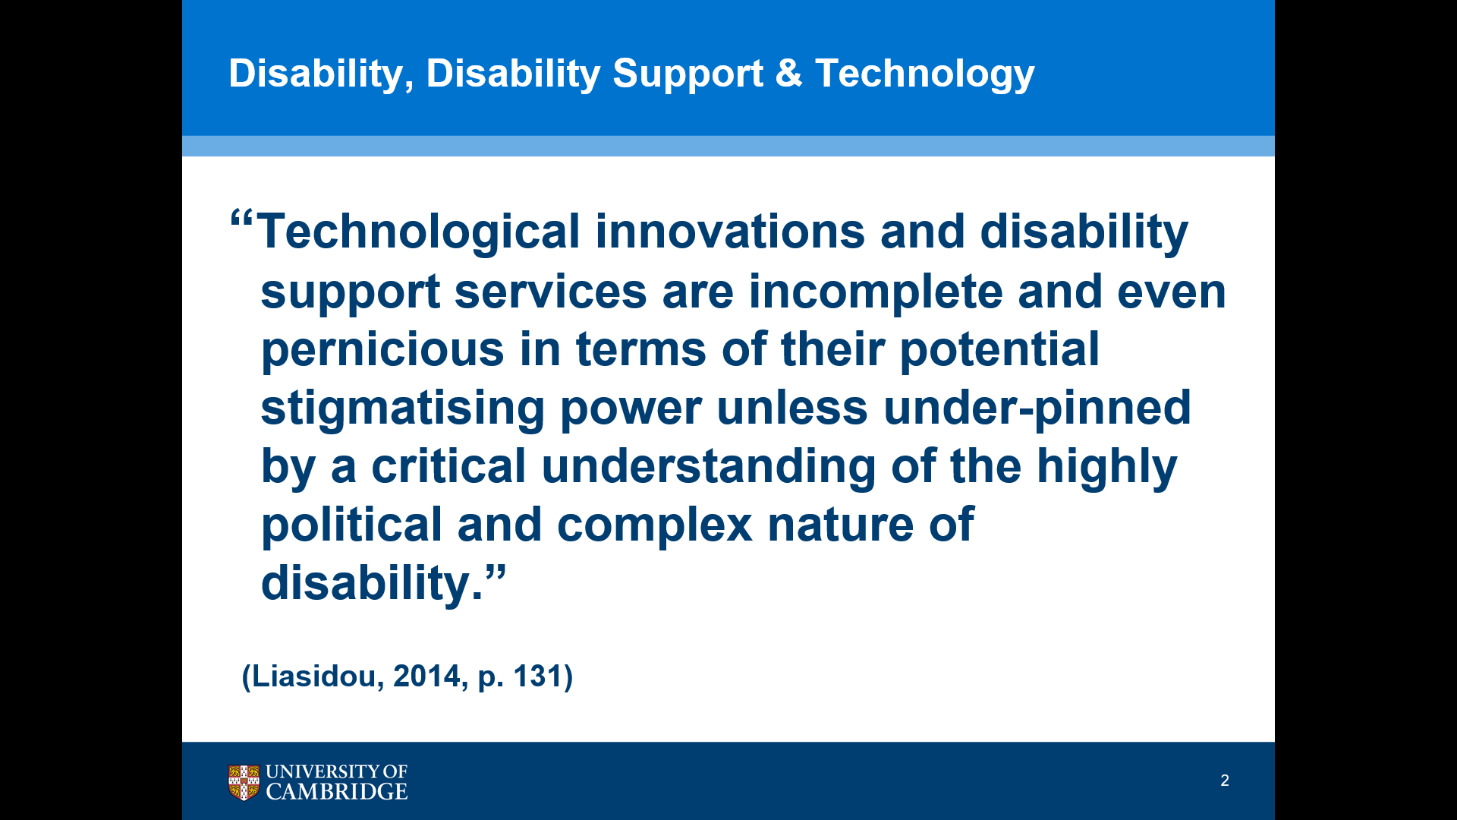
Just to start, I've got a thought-provoking quote from Liasidou (2014) which is…
"Technological innovations and disability support services are incomplete and even pernicious in terms of their potential stigmatising power unless underpinned by critical understanding of the highly political and complex nature of disability."
This is something I think is quite interesting because we often see accessibility and inclusion thought of after the fact almost as an add on rather than being involved in the in the design of teaching and learning. And I do feel sometimes disability services find themselves in quite a difficult position because the systems and the mechanisms that are set up for access to support or actually underpinned by a sort of medical or deficit model view of disability.

Slide 3: The role of assistive technology in inclusive practice
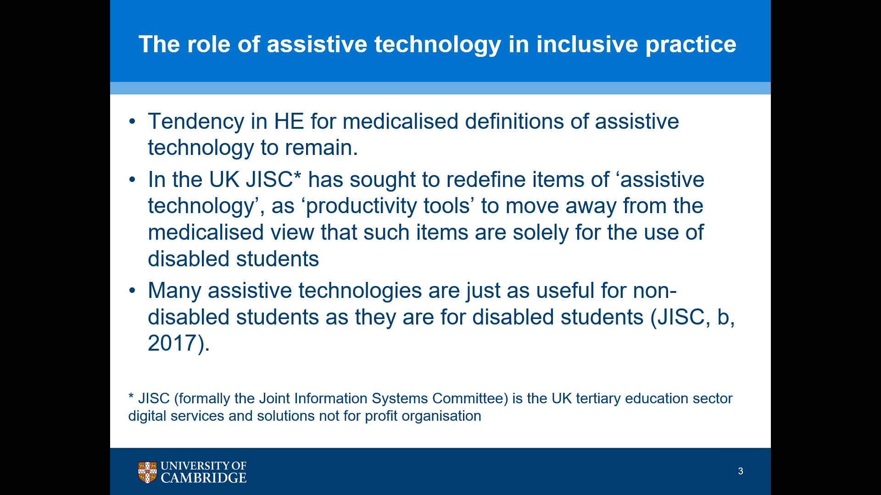
And, there is still a tendency in higher education for medicalised definitions of assistive technology to remain so in the UK, JISC have sought to redefine items of assistive technology as "productivity tools", so moving away from the medicalised view that such items are solely for the use of disabled students.
And as we know, many assistive technologies are just as useful for non-disabled students as they are for disabled students.
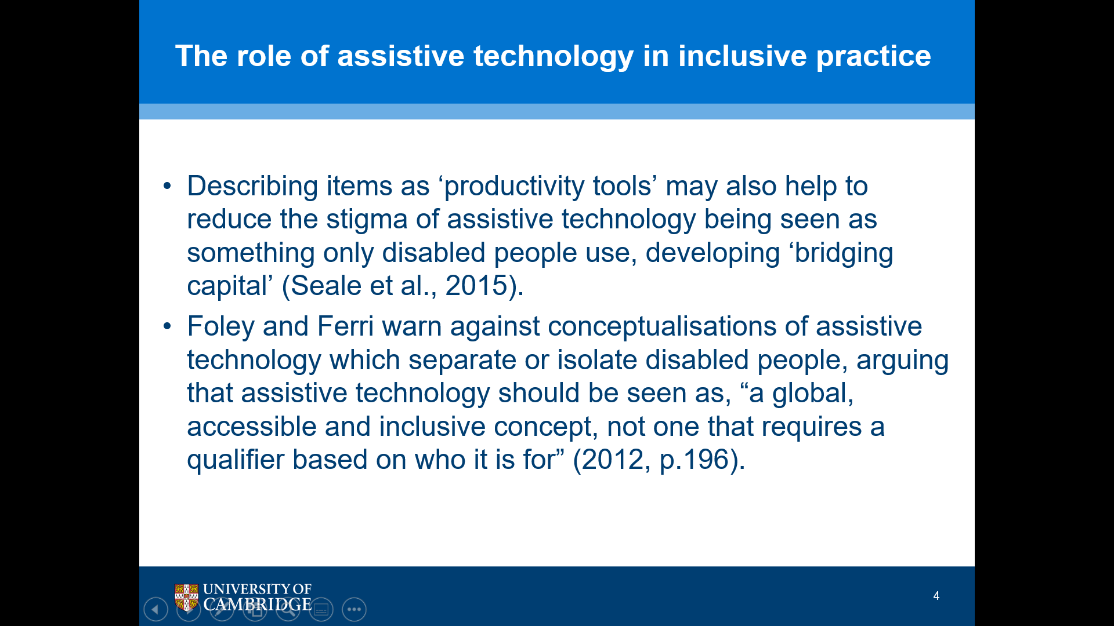
Slide 4: The role of assistive technology in inclusive practice

So, in an article by Seale et al. in 2015 they discuss describing items as 'productivity tools', helping to reduce the stigma of assistive technology being seen as something that's only for disabled people and developing what they call "bridging capital". And Foley and Ferri warn against conceptualisations of assistive technology which separate or isolate disabled people arguing that assistive technology should be seen as,
"a global, accessible and inclusive concept, not one that requires a qualifier based on who it is for" (2012:196)

Slide 5: Inclusion?
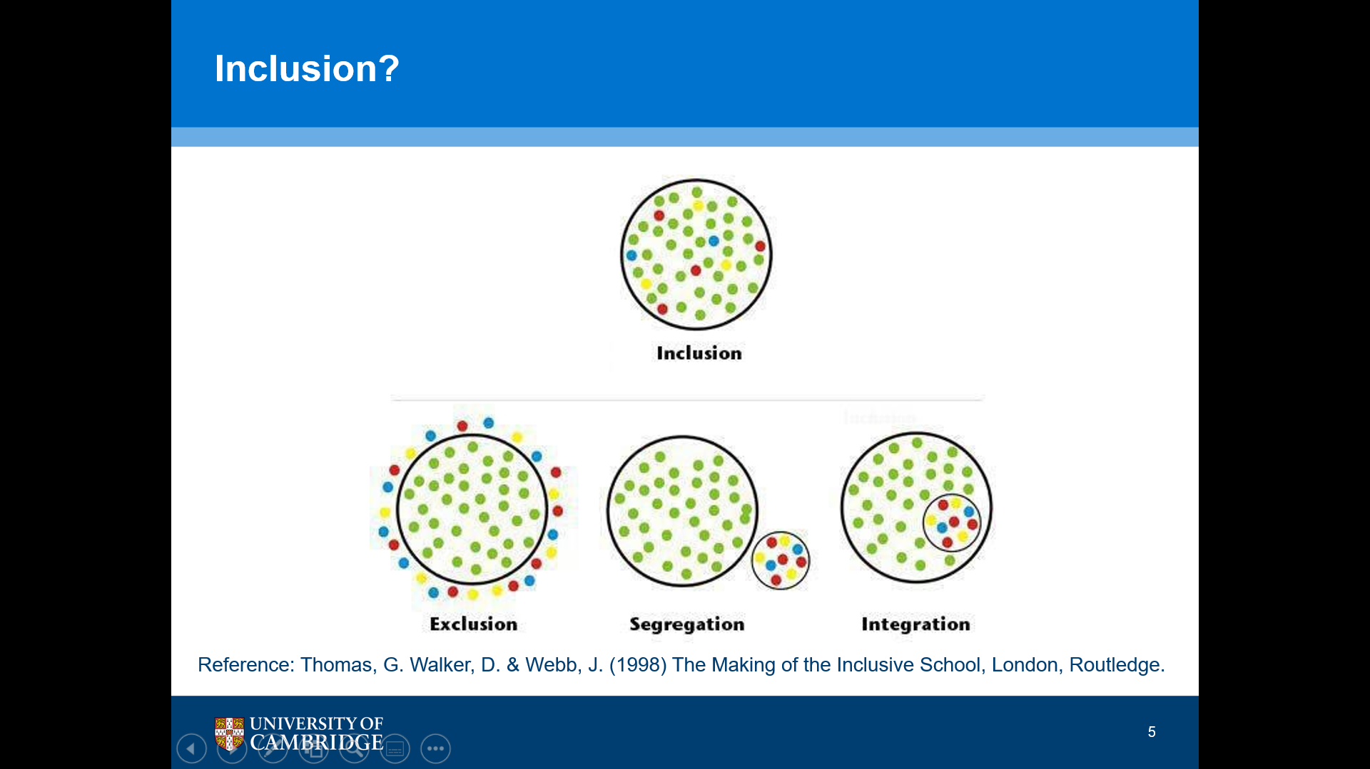
This is a diagram that I really like (Reference: Thomas, G. Walker, D. & Webb, J. (1998) The Making of the Inclusive School, London, Routledge).
So, just to describe it there are four larger circles and in all the circles there are some green dots and then in all of the images there are some coloured dots and at the bottom left of my screen is one entitled exclusion where the coloured dots sit outside the circle and the green dots sit inside the circle. And I suppose we could think about that in terms of, going back 30 or 40 years or maybe even closer, when disabled students really struggled to get into higher education so they were outside the system.
And then the middle bottom image there is a large circle with green dots within it, and then there's a smaller circle outside of it with the coloured dots. And for me, if we think about, say assessment, an example could be where we develop an alternative format for disabled students. So, they sit something that's quite different from that which is sat by their non-disabled peers.
And on the right at the bottom, you have the large circle with the green dots. And within that you have a smaller circle with coloured dots.
And, for me that is where we are, if you take assessment again as an example where perhaps, you know, we try and squeeze disabled students into an existing mode of assessment by making reasonable adjustments to try and fit them into the system rather than present the system that works well for them.
And then above the three circles we have one circle which has the coloured dots and the green dots. in the same circle. And for me if we take the assessment example again, then that could be a situation where we're offering students a choice or a range of modes of assessment. We're actually looking at the requirements and you know the circumstances that would benefit each student based on their own personal circumstances. So, I like that image. It is an example or explanation of inclusion.

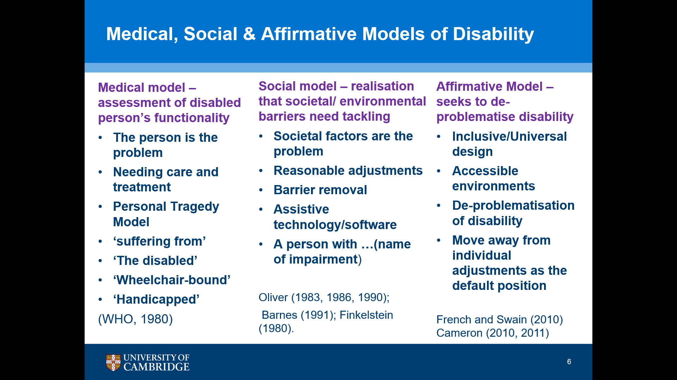
Slide 6: Medical, Social & Affirmative Models of Disability

This takes us to the medical, social and affirmative models of disability.
So, this this slide starts with the medical model where disability is situated with the individual. It's quite a deficit model, so it's problematic - the problems sits with the individual and then in the 1980s particularly Mike Oliver, the father of the social model and others developed the concept that says that disability is related to societal and contextual factors, so it's not related to the individual; it doesn't sit with the individual, it's the barriers that individuals face in society.
And then that was developed by French and Swain into the affirmative model where it's seeking to de-problematise disability, a recognition that disability is something that the vast majority of people will experience at some point during their lives, so normalising disability and acceptance that is part of part of life, part of society. And that's where the concept of Universal Design obviously comes in.

Slide 7: Universal Design for Learning
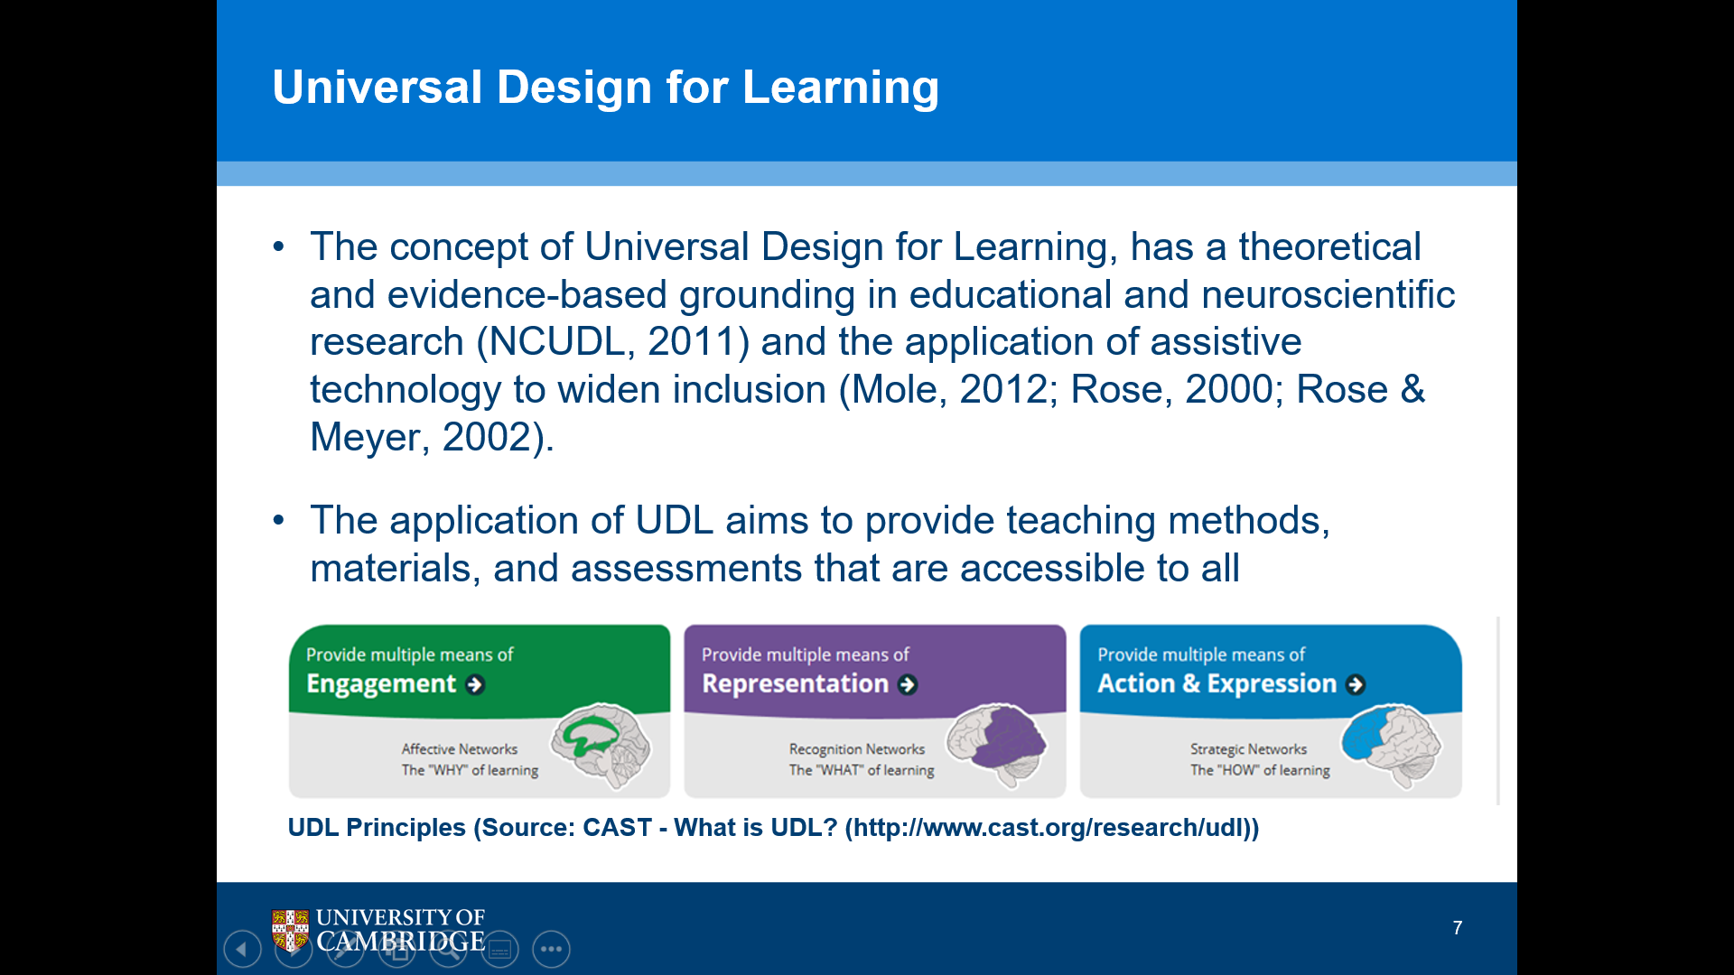

- The concept of Universal Design for Learning, has a theoretical and evidence-based grounding in educational and neuroscientific research (NCUDL, 2011) and the application of assistive technology to widen inclusion (Mole, 2012; Rose, 2000; Rose & Meyer, 2002).
- The application of UDL aims to provide teaching methods, materials, and assessments that are accessible to all
UDL Principles (Source: CAST - What is UDL? (http://www.cast.org/research/udl ))
So Universal Design has got a theoretical and evidence-based grounding in educational and neuroscientific research and the application of assistive technology to widen inclusion and the aim of UDL is to provide teaching methods, materials and assessments that are accessible to all.

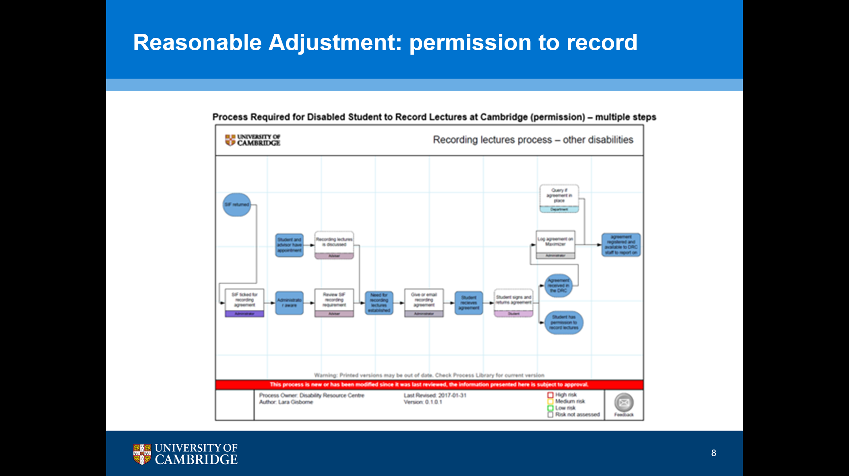
Slide 8: Reasonable Adjustment: permission to record

I think a good example and I'll lead onto the research that I'm doing now of the movement from reasonable adjustment to inclusive practice is, if you look at this flow chart here and I'm not expecting you to read it, the image there so you can see that there are multiple steps, is that this is the existing process in my University for a student to request permission to record, and in my research is around lecture capture technology.
So, in those areas where the student has access to lecture capture technology, they don't need to ask for permission to record. So, this is the process in those areas where it doesn't exist.

Slide 9: Universal Design: Lecture Capture
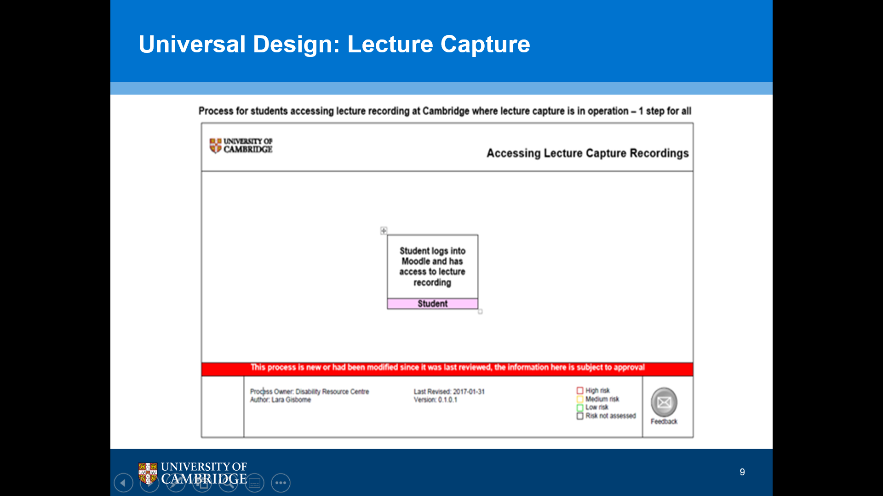

And this is the process where it does exist.
The student, the disabled student, can access their learning in exactly the same way as the non-disabled peers. They might not even need to disclose.
So, they go on to the University's VLE, we use Moodle, and the information is there for them.
They don't have to ask for permission, they don't have to go through
that lengthy process and I think that's a really good example.

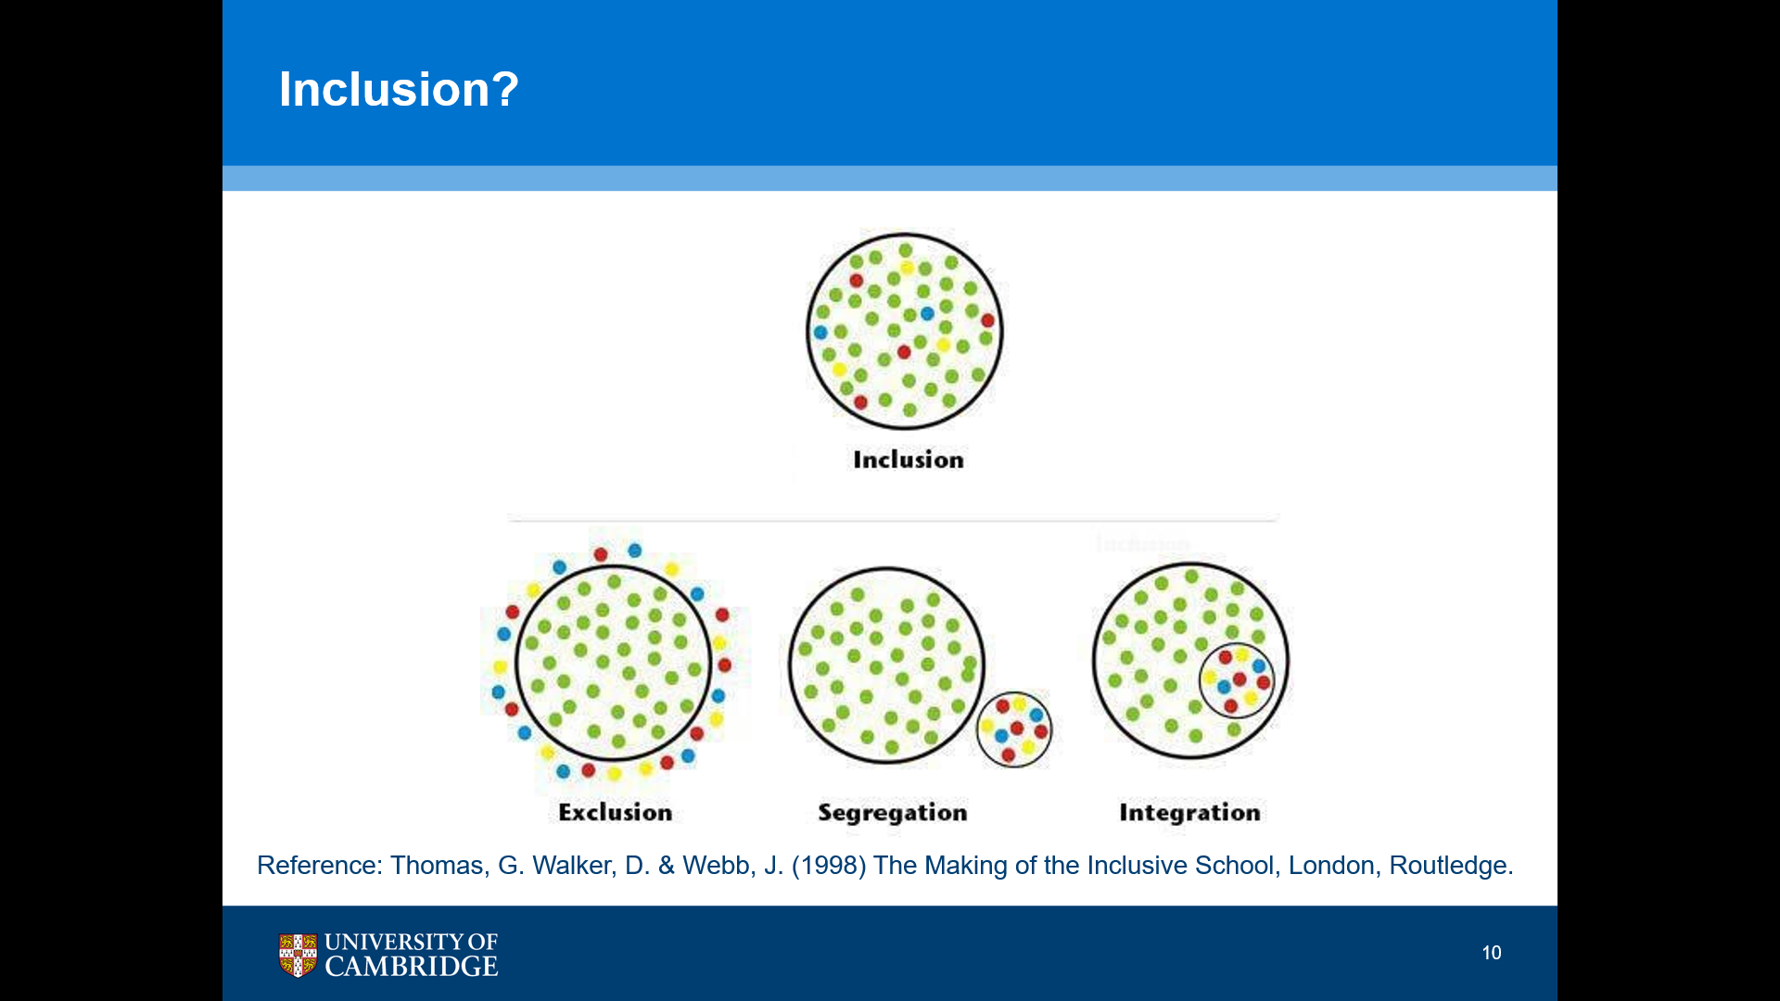
Slide 10: Inclusion?

And it takes me back to the image that I showed you before of the four major circles, and I think if you look at the top circle where all of the dots are together in one circle, that's a good example of what lecture capture does. Whereas asking for permission to record is obviously an attempt to integrate students, but you're still asking them to do something separate and something in addition to that which you're not asking, non-disabled students.

Slide 11: My Research Questions
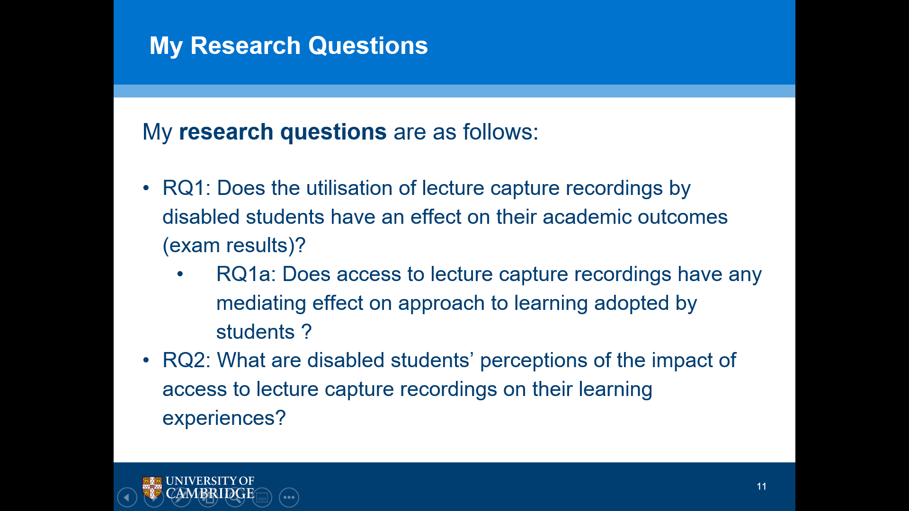

So, as I said, my focus is lecture capture. So, these are my research questions.
So, the first question is, “does the utilisation of lecture capture recordings by disabled students have an effect on their academic outcomes?”
And then there's a sub-question there: “does access to lecture capture recordings have any mediating effect on approaches to learning adopted by students?”
And a separate, second question is “what are disabled students’ perceptions of the impact of access to lecture capture recordings on their learning experiences?”

Slide 12: Methodology – mixed methods
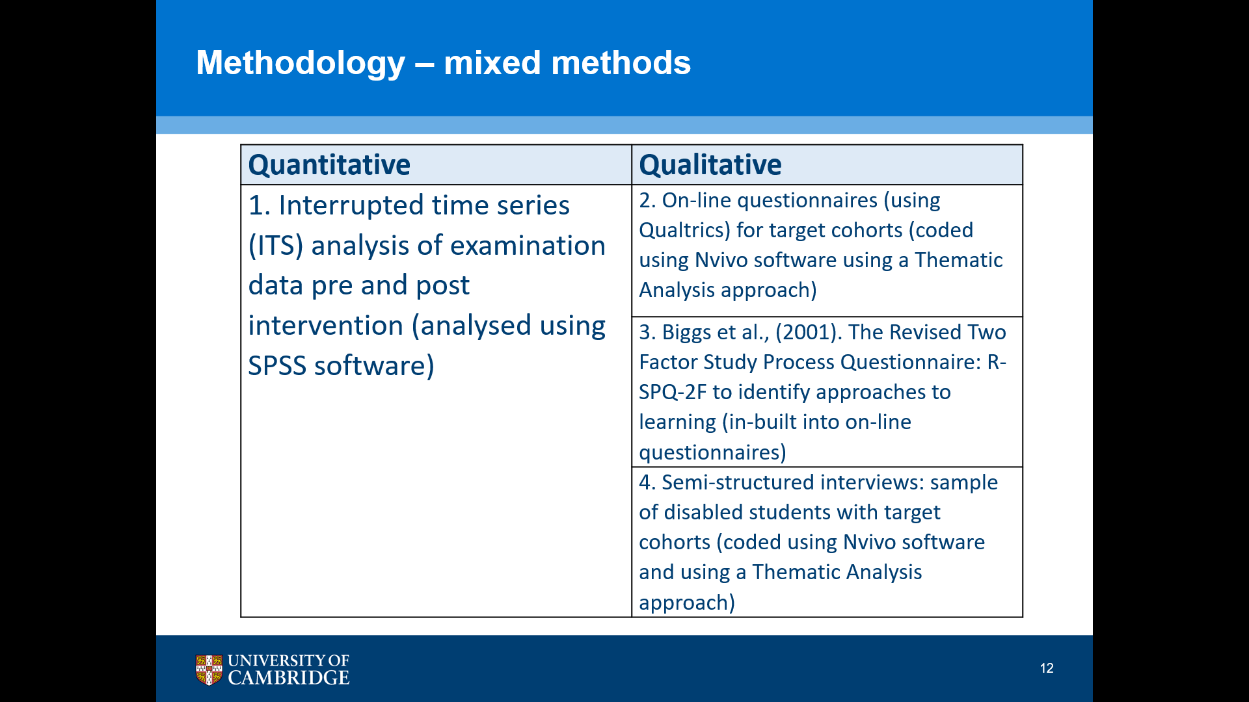

And it's a mixed method study. So, on the quantitative side, I've got five years' data pre-lecture capture being introduced as a pilot and then 3 three years' data post-implementation and to analyse that I'm doing an interrupted time series analysis (ITS). Analysed using SPSS software.
And on the qualitative side, I've then got online questionnaires which students who within the lecture capture pilot completed every year over the three-year period. (coded using NVivo software using a thematic analysis approach).
And I've also done some semi-structured interviews with students who completed the questionnaires and then for the second research question I'm using an instrument called the Revised Two Factor Study Process Questionnaire which was developed by John Biggs (2001) who's an Australian academic, worked a lot in Hong Kong. And, that's basically looking at students' approaches to learning. So, the sort of deep and surface approach with some subscales.

Slide 13: Scope of the Study
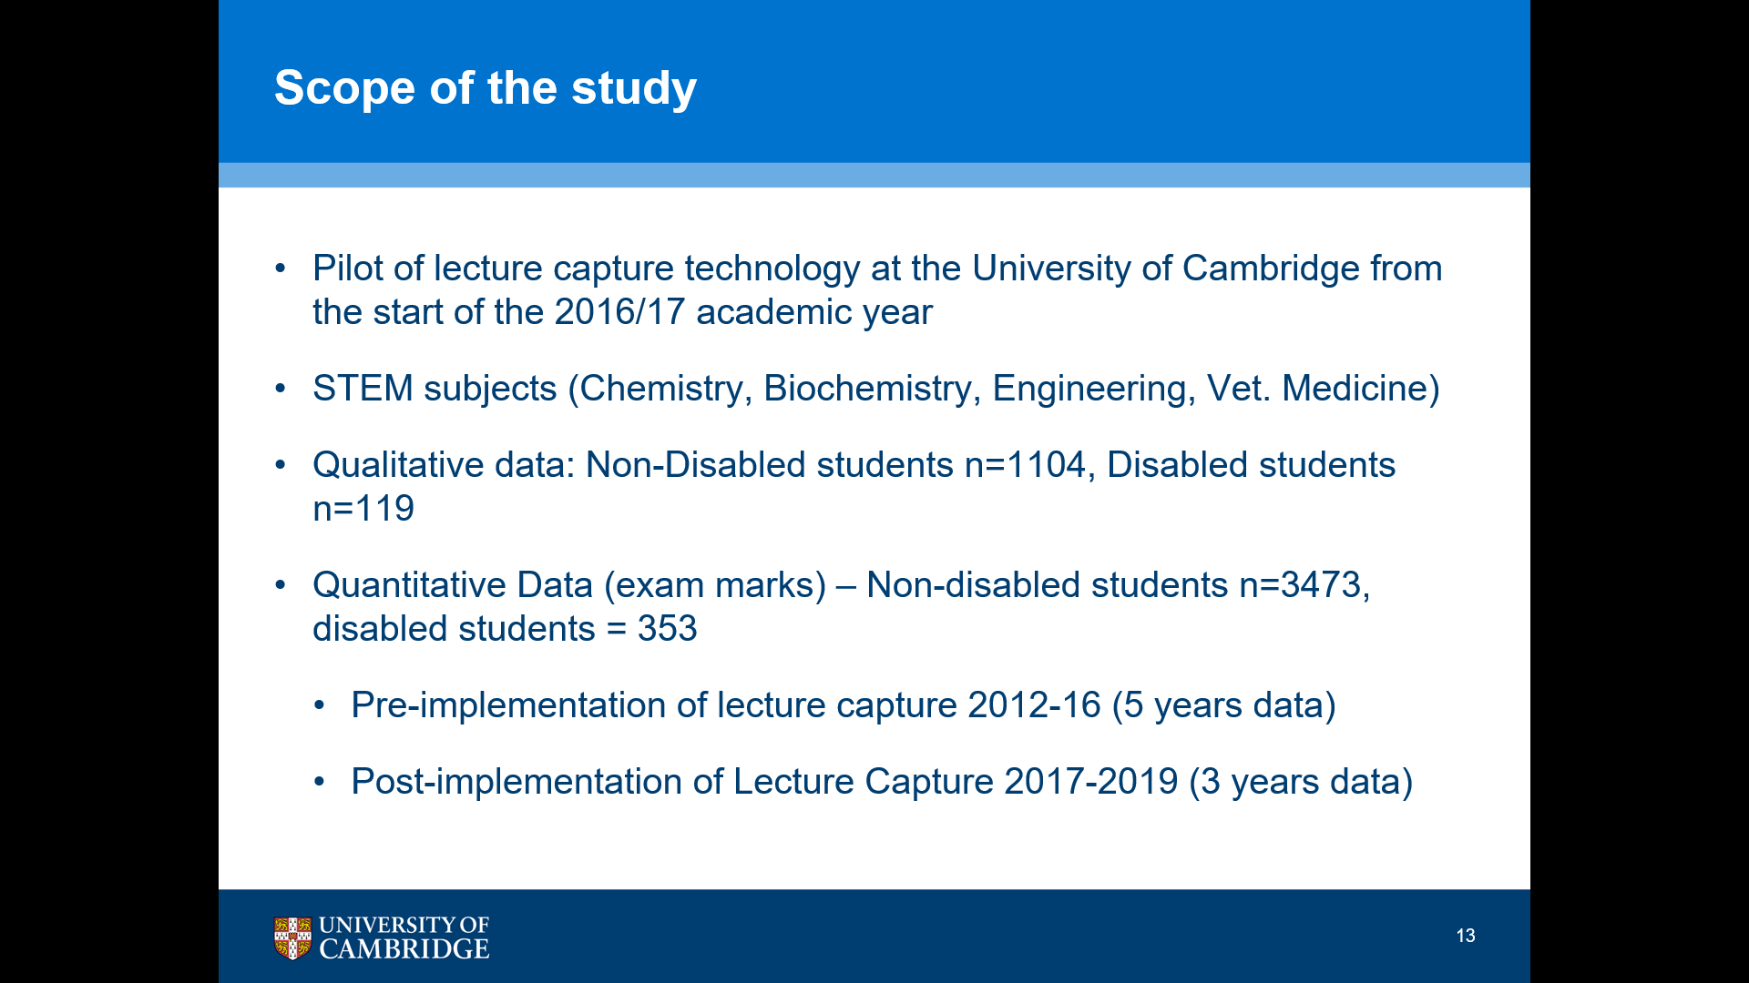

So, the scope of the study was the pilot of lecture capture technology at the University of Cambridge from the start of the 2016/17 academic year.
The focus is in STEM subjects because those were the subjects that were part of the pilot. So, chemistry, biochemistry, engineering and vet medicine.
In the qualitative data there were over 1000 non-disabled students and over 100 disabled students and in the quantitative data, for the exam marks, it was the larger cohort, so nearly 3500 non-disabled students and 353 disabled students.
And so, as I said before, I had five years' data pre lecture capture (examination data) and then three years' data after the implementation of lecture capture.

Slide 14: Initial findings from study

Cohort | N= | Mean Exam score 2012-16 (Pre-Lecture Capture) | Mean Exam score 2017-19 (Post-Lecture Capture) | Difference
Non-Disabled | 3,473 | 63.09% | 63.67% | + 0.58
Disabled | 353 | 60.52% | 61.31% | + 0.79
SpLD | 184 | 59.82% | 60.30% | + 0.48
Mental Health | 74 | 59.43% | 59.59% | + 0.16

So, initial findings from the study, and I have to say at this point that I have not completed the analysis of the data. A lot of that has been impacted by the pandemic and loss of time to study and I'll explain a little bit more about that later.
So, if you look at the data:
Does utilisation of lecture capture recordings by disabled students have an effect on their academic outcomes?
Then you can see that in all areas, including non-disabled students, there's a slight increase in the mean examination mark between the five years pre-lecture capture and three years post-lecture capture.
And I don't think that that is really surprising because I was not expecting or anticipating that the implementation of that one particular, change in delivery would make a significant impact, but I think the interesting thing you see in the data is the consistent difference in gap between the performance of non-disabled students and the performance of disabled students, with some slight difference depending on impairment type and for me that might be telling us something more about the way in which we assess students them than the mode of delivery, but I still need to do the statistical analysis. But I would be very surprised if any of those come out as being significant, but it's interesting data.

Slide 15: Initial Findings from study
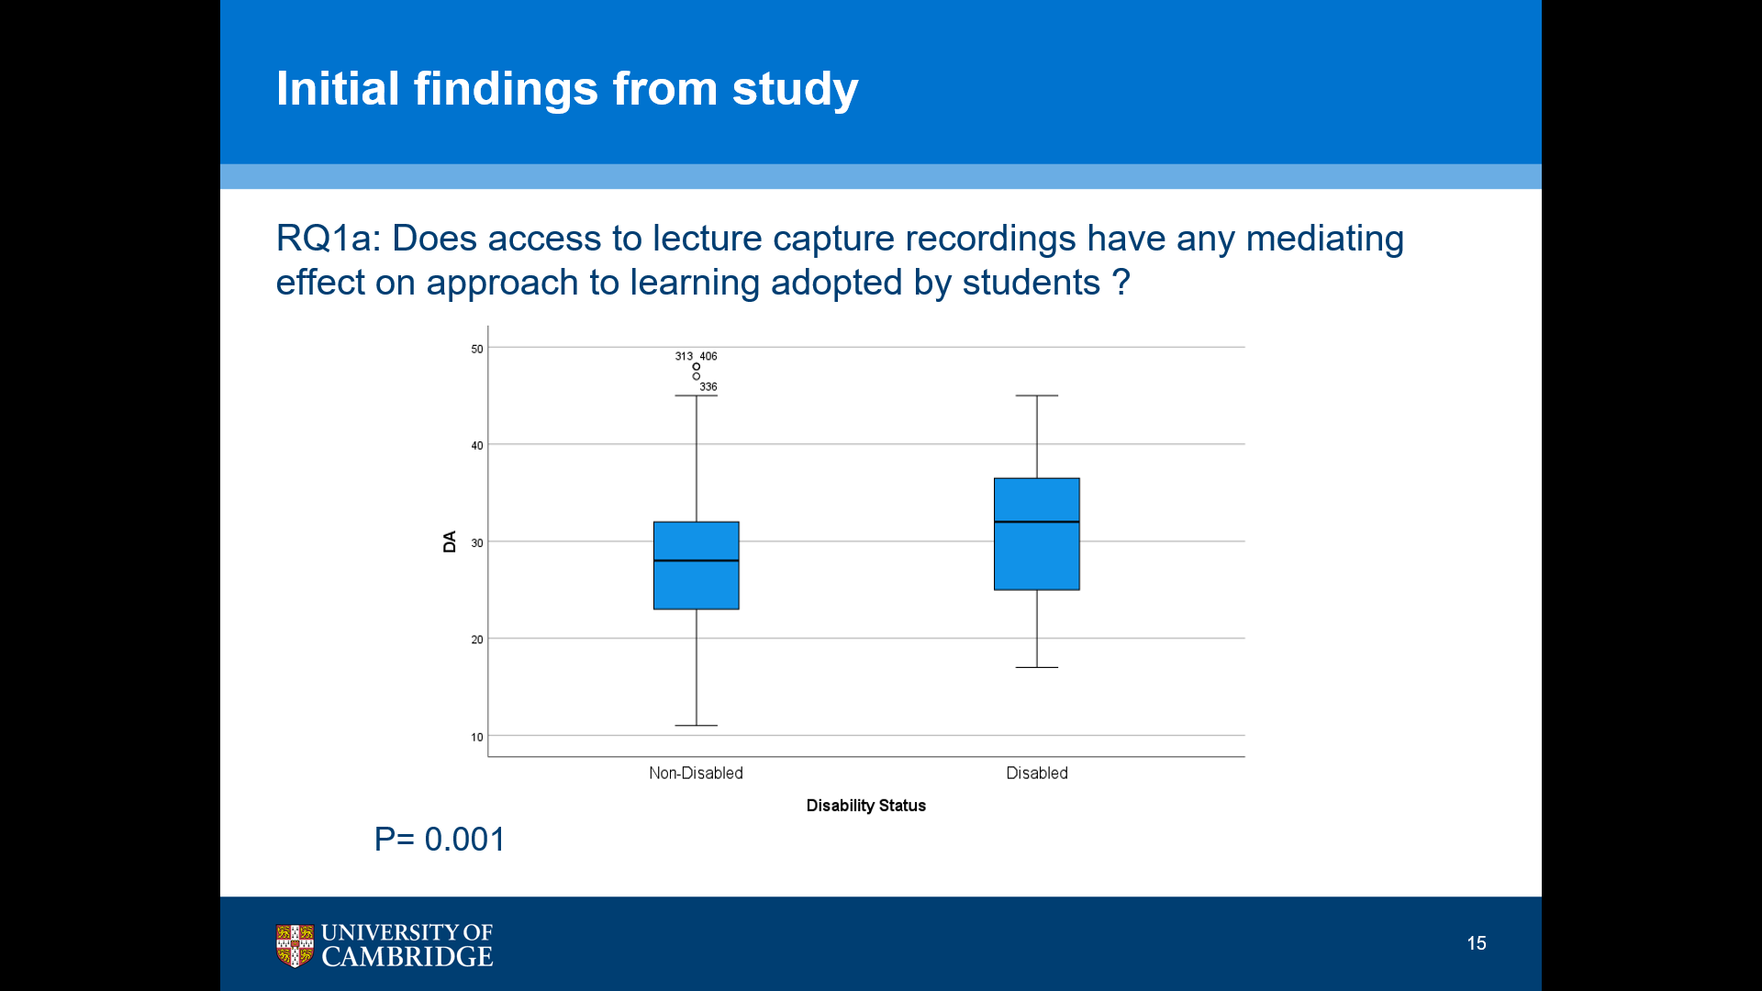

And this was research question 1A, around mediating effect on approaches to learning by disabled students, and this is the… It's a box and whisker diagram of the analysis of the ratings that that students, disabled students and non-disabled students resulted in around deep approaches to learning, and there is actually a statistically significant difference here with disabled students having a much higher mean score on deep approaches, than non-disabled students and this is something that I'm looking into at the moment and looking at other variables to see whether it's the influence of particular aspects of the usage of lecture capture that has driven this change. To see if there's any significance there. But again, I'm only in the in the first stages of that analysis.

Slide 16: Initial findings from study
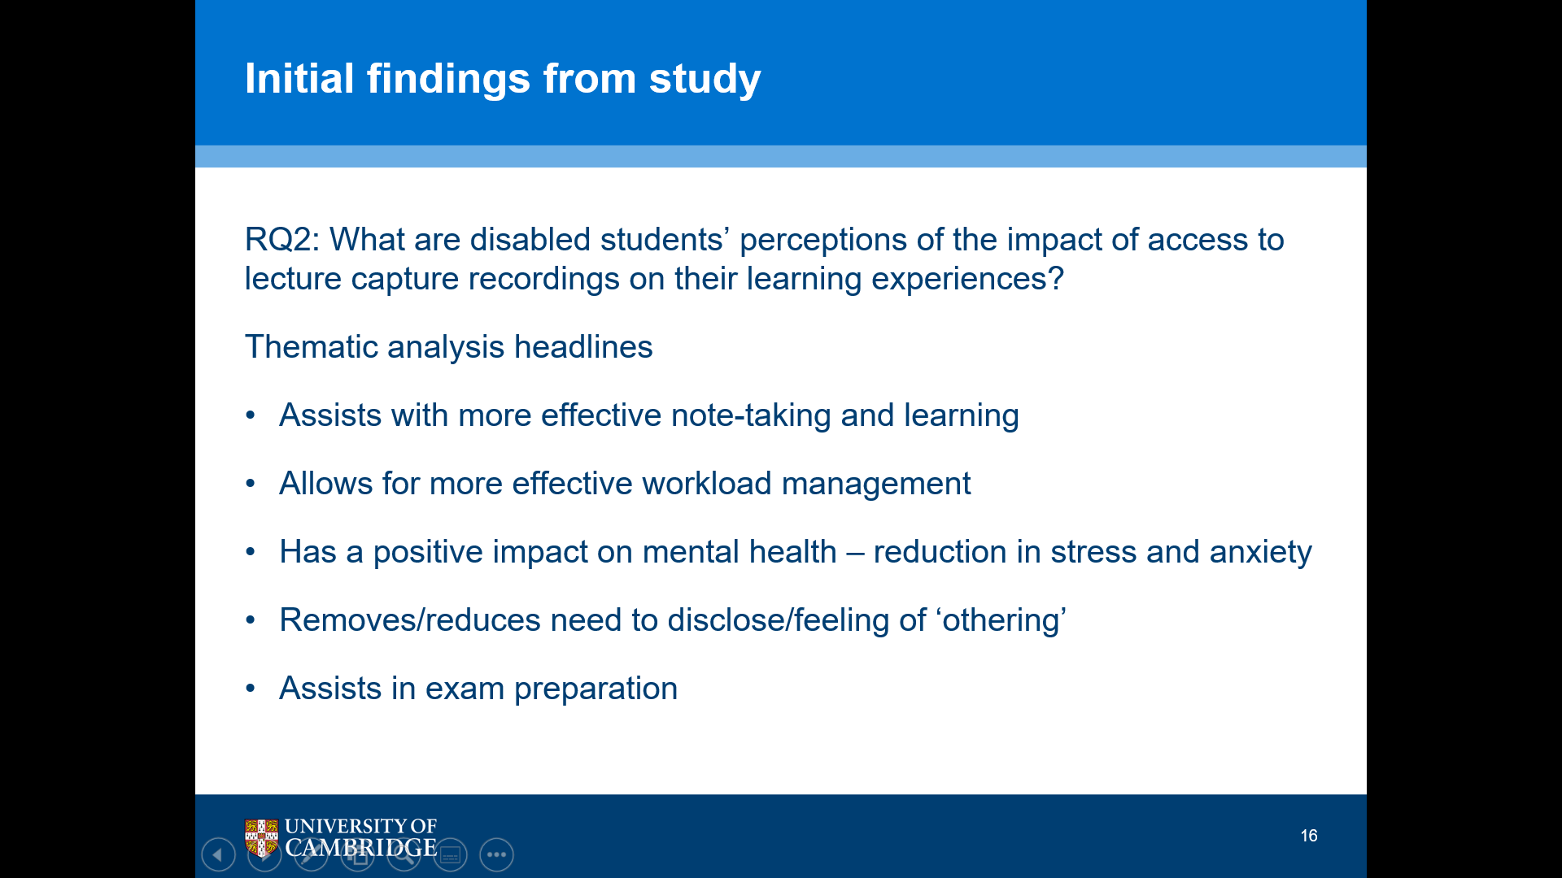

And then in the second main research question about students' perceptions or self-reports of the impact of access to lecture capture recordings on the learning experience.
From the initial thematic analysis, students report that the access to lecture capture…
- Assists with more effective notetaking and learning.
- It allows for more effective workload management.
- They can pace themselves better.
- It has a positive impact on mental health, a reduction in stress and anxiety.
- Students aren't worried that if they miss a lecture that's the only chance they would have to access that information.
- And also from a disability perspective it reduces or even removes, the need to disclose their disability and takes away that that that feeling of othering.
- And it also assists in exam preparation.

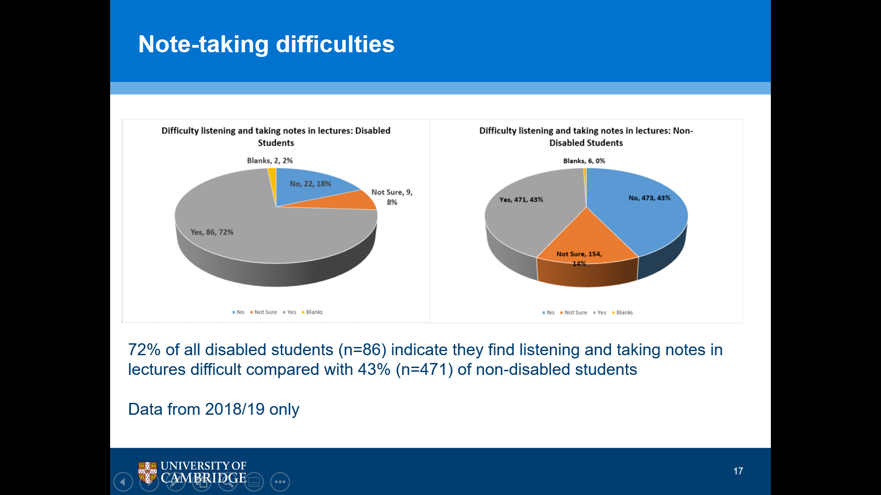
Slide 17: Note-taking difficulties

And this is quite interesting around self-reported notetaking difficulties. So, the question was "do you have difficulty listening and taking notes in lectures?" and the image we have here is 2 pie charts that sit side to side.
The first one focuses on the responses from disabled students.
The second one, responses from non-disabled students and it shows that 72% of all disabled students indicated that they find listening and taking notes in lectures difficult. Compared to only 43% of non-disabled students.

Slide 18: Reported improvement in note-taking
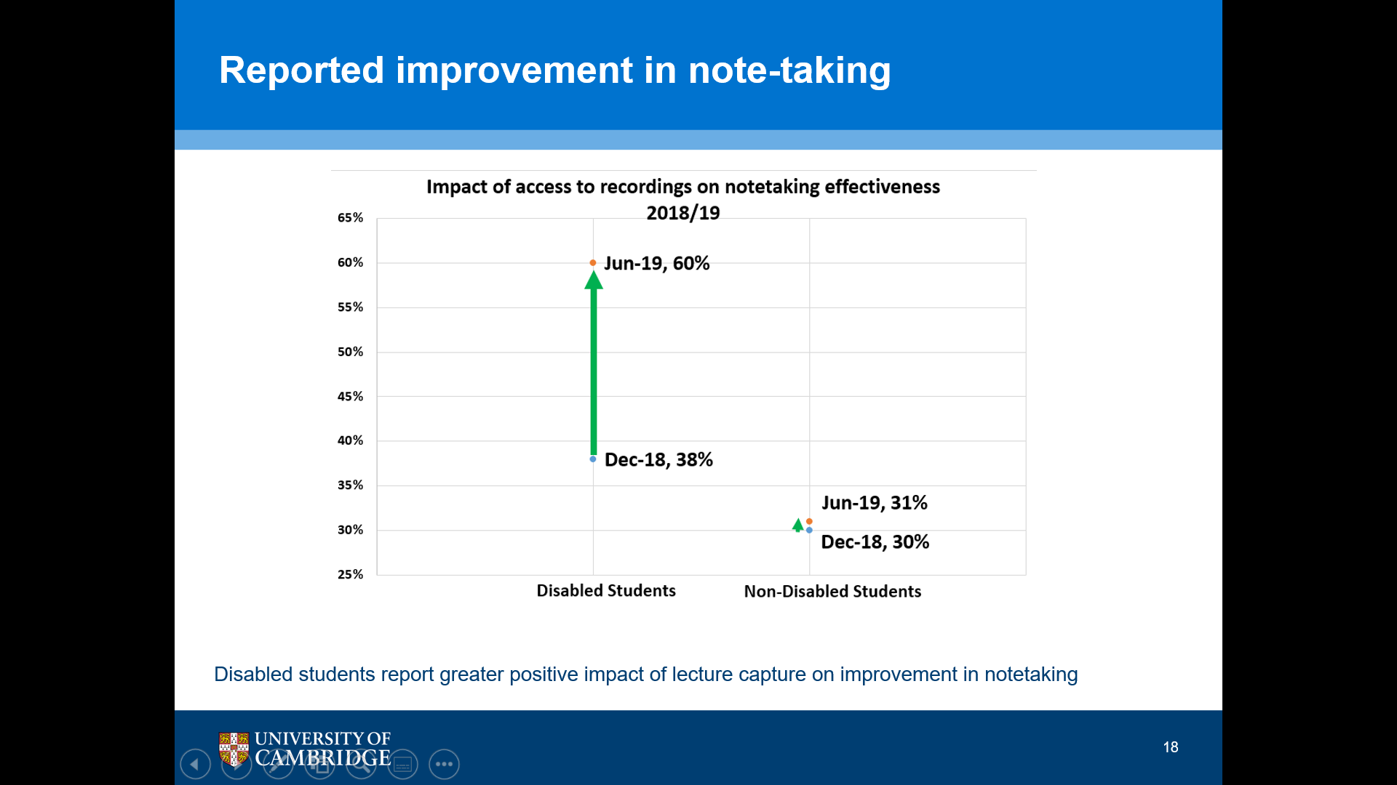

And then when I asked students about improvements in the note taking and this was at two points during the year. So, after the first term and after the third term. There's quite a marked difference between the responses of disabled students and non-disabled students from the first term to the third term and the image that's on the screen now is a graphic which shows the extent of the difference in the responses of students between that first and third term.
So, for disabled students, 38% reported after the first term that they felt that that the impact of lecture capture had improved their notetaking, but then at the end of the third term that had risen to 60% But, for non-disabled students, at the end of the first term, it was 30% who indicated that note taking had improved, but at the end of the third term that had only gone up by 1% to 31%
So, as disabled students went through the academic year their reporting of improvement in notetaking increased significantly more than that of non-disabled students.

Slide 19: Impact on mental health and wellbeing
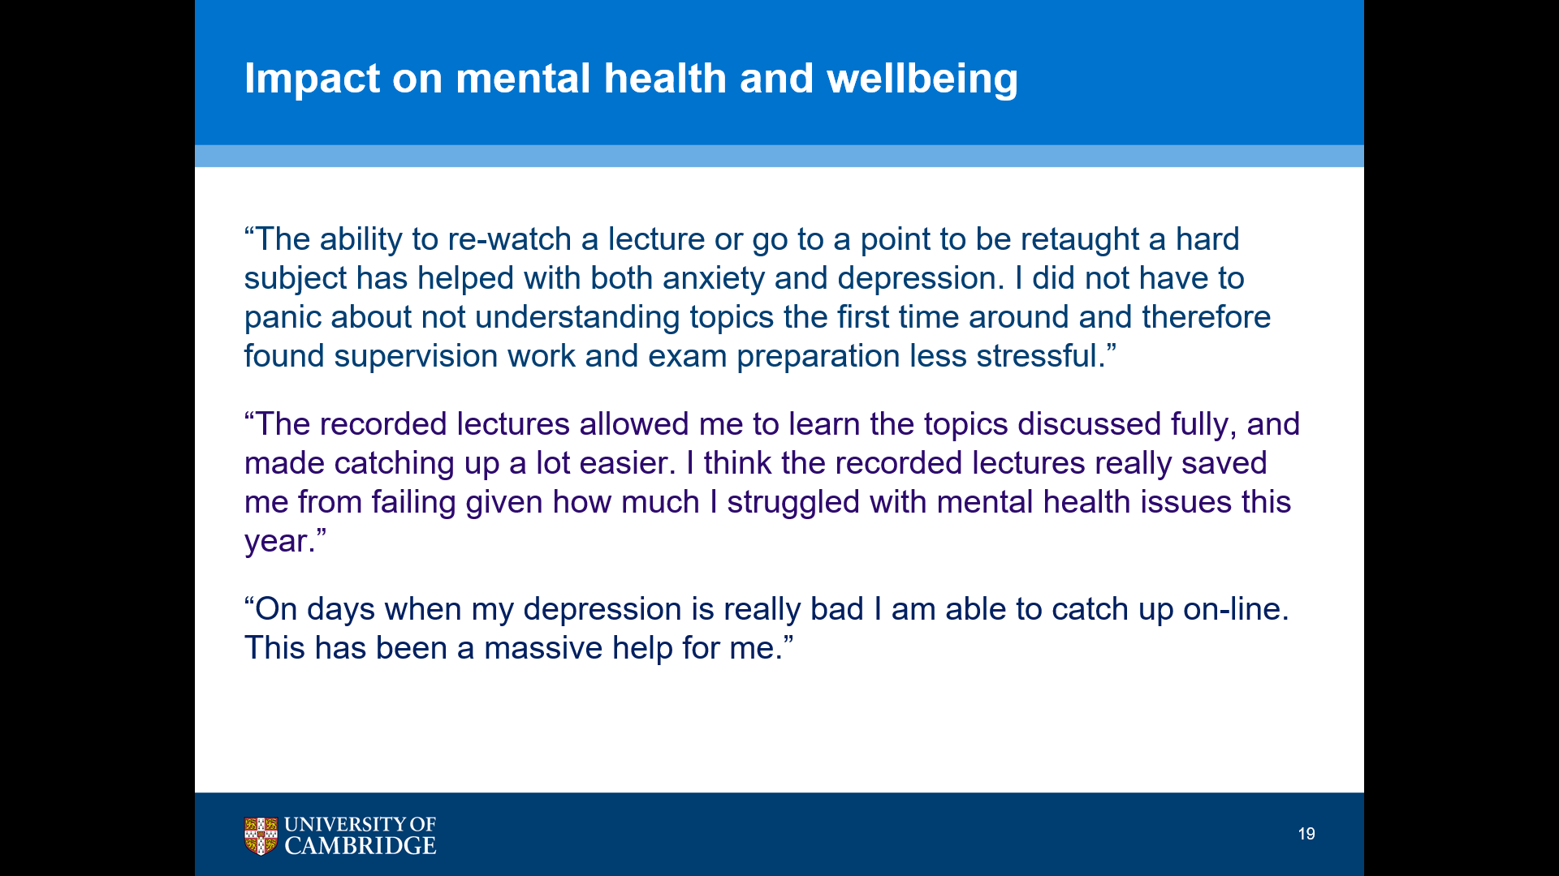

And what's really interesting, and I think this is obviously very relevant when we think about the pandemic and the move to almost exclusively online learning, that the students reported a real impact on the mental health and wellbeing, and these quotes are from disabled students. But there were other quotes that were from non-disabled students as well.
So, the first quote is:
"The ability to re-watch a lecture or go to a point to be retaught a hard subject has helped with both anxiety and depression. I did not have to panic about not understanding topics the first time around and therefore found supervision work and exam preparation less stressful."
And the second quote is:
"The recorded lectures allowed me to learn the topics discussed fully and made catching up a lot easier. I think the recorded lectures really saved me from failing, giving how much I struggled with mental health issues this year."
And the final quote is:
"On days when my depression is really bad, I'm able to catch up online and this has been a massive help for me."

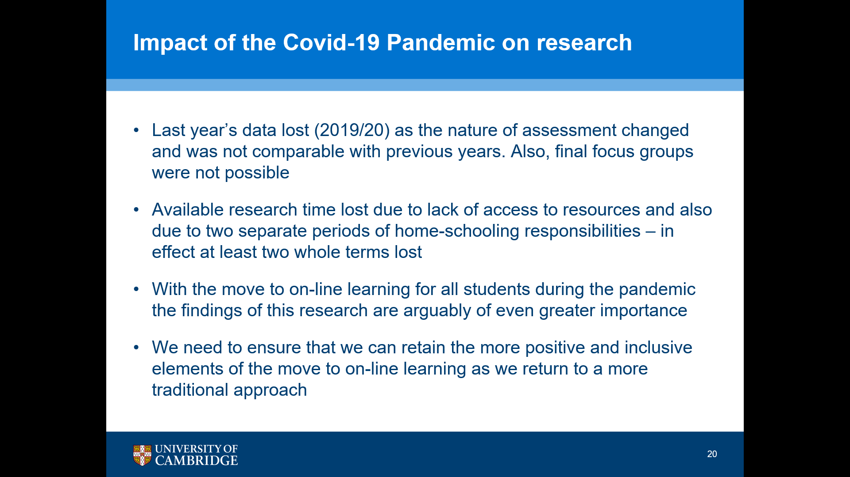
Slide 20: Impact of the Covid-19 Pandemic on research

So just a little bit about the impact of the COVID-19 pandemic on my research, and I think it's really important for everyone to reflect on the impact this has had on both on academic staff and students.
In effect, the first lockdown lost me my last year's data because it was based on both their examination and assessment, but also on questionnaires that required two points across the year so, the assessment obviously changed in nature, the nature of the assessment wasn't comparable and also the final focus groups and questionnaires weren't possible.
Then I also lost a lot of research time due to both not being able to access University resources, but also, as I've got three children and we've had two separate periods of homeschooling responsibilities, the last of which hopefully is about to finish very soon! And that lost me two terms.
But, with the move to online learning for all students, during the pandemic, I do think that this research or the findings of this researcher I could be even greater importance than they would have been, and it's my personal view that we need to ensure that we can retain the more positive and inclusive elements of the move to online learning as we return, potentially, to do a more traditional or blended approach.

Slide 21: Do you agree with this statement?
“Technological innovations and disability support services are incomplete and even pernicious in terms of their potential stigmatising power unless under-pinned by a critical understanding of the highly political and complex nature of disability.”
(Liasidou, 2014, p. 131)
And so, I was asked to end with a question that you could reflect and comment on. So, I'll go back to the quote that I started the presentation with, and my question to you is,
Do you agree with this statement?
And it would be interesting to know your thoughts.

Slide 22-25: References
So, these slides contain my references.
- Barnes, C. (1991). Disabled people in Britain and discrimination: A case for anti-discrimination legislation. London. Hurst and Co.
- Cameron, C. (2010). Does anybody like being disabled? A critical exploration of impairment, identity, media and everyday experience in a disabling society. (Doctoral dissertation, Queen Margaret University).
- Cameron, C. (2011). Not our problem: impairment as difference, disability as role. Journal of Inclusive Practice in Further and Higher Education, 3(2), 10-25.
- Cameron, C. (2014). Nothing To Do With Me: Everything To Do With Me. Disability, Self and Identity. Retrieved February 19, 2018, from https://www.disabilityartsonline.org.uk/domains/disabilityarts.org/local/media/audio/Nothing_To_Do_With_Me_ FINAL. pdf.
- Finkelstein, V. (2001). The social model of disability repossessed. Manchester Coalition of Disabled People, 1.
- Foley, A., & Ferri, B. A. (2012). Technology for people, not disabilities: ensuring access and inclusion. Journal of Research in Special Educational Needs, 12(4), 192-200.
- French, S., & Swain, J. (2004). Whose tragedy?: Towards a personal non-tragedy view of disability. Sage
- Gibson, S. (2015). When rights are not enough: What is? Moving towards new pedagogy for inclusive education within UK universities. International Journal of Inclusive Education, 19(8), 875-886.
- Hockings . C. (2010) Inclusive learning and teaching in higher education: a synthesis of research. EvidenceNet. York. HEA.
- Jisc (2017). Using assistive and accessible technology in teaching and learning. Retrieved on 26 July 2017 from https://www.jisc.ac.uk/guides/using-assistive-and-accessible-technology-in-teaching-and-learning
- Liasidou, A. (2014). Critical disability studies and socially just change in higher education. British Journal of Special Education, 41(2), 120-135.
- May, H., & Bridger, K. (2010). Developing and embedding inclusive policy and practice in higher education. York: Higher Education Academy.
- Mole, H. (2012). A US model for inclusion of disabled students in higher education settings: the social model of disability and universal design. Widening Participation & Lifelong Learning, 14(3), 62–86.
- National Centre for Universal Design for Learning (NCUDL) https://medium.com/udl-center
- Oliver, M. (1983). Social Work with Disabled People. Basingstoke, Macmillan.
- Oliver, M. (1986). Social policy and disability: some theoretical issues. Disability & society, 1(1), 5-17.
- Oliver, M. (1990, July). The individual and social models of disability. In Joint workshop of the living options Group and the Research Unit of the Royal College of Physicians (Vol. 23).
- Pisha, B., & Coyne, P. (2001). Smart from the start: The promise of universal design for learning. Remedial and special education, 22(4), 197-203.
- Rose, D. (2000). Universal design for learning. Journal of Special Education Technology, 15(3), 45-49.
- Rose, D. H., & Meyer, A. (2002). Teaching every student in the digital age: Universal design for learning. Association for Supervision and Curriculum Development, 1703 N. Beauregard St., Alexandria, VA. 22311-1714.
- Seale, J., Georgeson, J., Mamas, C., & Swain, J. (2015). Not the right kind of ‘digital capital’? An examination of the complex relationship between disabled students, their technologies and higher education institutions. Computers & Education, 82, 118-128.
Images
- Slide 7 graphic (Source: CAST - What is UDL? (http://www.cast.org/research/udl))
- Slide 5 &10 graphic (Reference: Thomas, G. Walker, D. & Webb, J. (1998) The Making of the Inclusive School, London, Routledge).
I'm more than happy to be contacted about the presentation of my research.

