Pre-task 2: The Social Model of Disability at UAL

1. Watch the following two-minute video

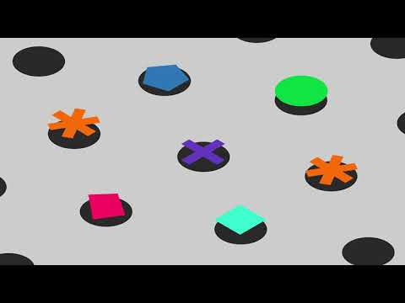

- Available at: https://www.youtube.com/watch?v=mNdnjmcrzgw
- Audio described version: https://www.youtube.com/watch?v=NsEIa1wLfmQ
- A transcript is available on the following page.

2. Write about how the social model of disability might apply to your area of work. We’re thinking about 100 words, but feel free to respond however works best for you.

Transcript of video: The Social Model of Disability at UAL

UAL and the Disability Service use the social model of disability as a tool to support students. Here’s what this means for you.

Have you ever felt like the world isn’t designed for you? Like you don’t fit in?

Each and every one of us is different – but it can feel like the world expects us all to be the same.

Every day I encounter barriers, and things that disable me.

Sometimes it’s the building, or an offhand comment that gets in my way

It can feel like my course is taught and assessed in a way that doesn’t have me in mind

Sometimes I feel like I have to tell people my life story, just to get what I need.

But it doesn’t need to be that way.

The social model of disability says that we are not disabled by our individual differences. We are disabled by barriers in the world around us.

We are disabled by a world that doesn’t take into account who we are, and what we need.

We don’t need to change who we are. We can change the world around us.

We can change buildings, and courses, and attitudes.

In a university full of artists, designers and creatives, we can create a university that’s designed with everyone in mind.

A university that removes barriers for everyone, whoever we are.

We can shape the world around us. And the Disability Service can help.

